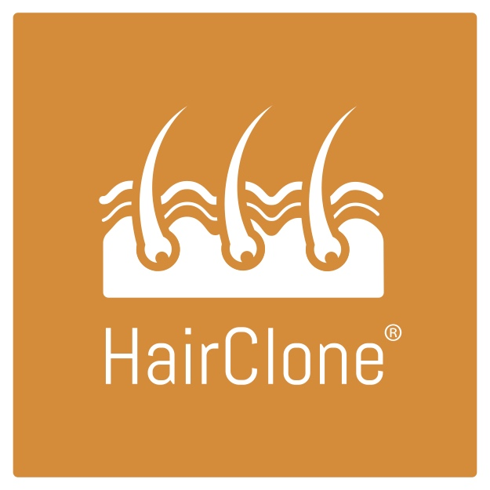
HairClone, a PIONEERING biotech start-up headquartered in Manchester, has been granted a licence by UK regulators to launch the world’s first follicle banking service - the first stage in their goal to make hair loss history.

Biotechnology firm HairClone, headquartered in the UK, says it wants to ‘make hair loss a thing of the past’.

And as a major first step towards this, HairClone, in partnership with a licensed UK Tissue Bank, has now been authorised by the UK regulators to launch the world’s first ever hair follicle banking system.

Male and female patients who are concerned about hair loss can now have some of their hair follicles, cryopreserved and stored for future available treatments.

Respected hair restoration surgeon Dr Bessam Farjo, founder of the Farjo Hair Institute and Medical Director of HairClone, said: “Now that the licence is in place we’re ready to bank hair for patients and consultations can begin in earnest, we are contacted every day by people concerned about hair loss asking when it will be ready

Hair follicle banking will be open to all adults, aged 18 and over, and the banking costs will be similar to other established tissue banking procedures (for example core blood and tissue) which currently costs around £2,000

In the HairClone banking process, the patient and surgeon will first decide whether banking is a good option. Then around a hundred hair follicles will be removed from the back of patient’s head in a simple surgical procedure which will take less than an hour and patients should be able to continue with their regular activities right afterwards. The follicles will then be carefully cryopreserved to maintain cell viability, before being stored at minus 180 C at HairClone’s partner tissue bank.

HairClone is developing a personalised treatment that will use cells from a patient’s banked hair follicles to rebuild the miniaturised hairs caused by androgenic alopecia. In this treatment, some of the banked follicles will be carefully thawed and the relevant cells multiplied (cloned) and transported back to the surgery where they will be implanted back into the scalp through a series of small injections. Early work has indicated that these cells are able to replace those lost in the miniaturised hairs, rebuilding them to their original thickness and length.

Dr Farjo explains why a patients would want to bank their hair now before the treatments are available. "By taking follicles at the earliest age possible, the cells will be preserved and stored when they are young and are optimally viable. It’s been shown that the number of cells within a hair follicle steadily declines as we age. Storing the follicles at these ultra-low temperatures then “stops the clock” on their ageing”
Banking also allows for multiple personalised cell therapies over many years using the original follicles obtained from the one procedure because only a fraction of the hair follicles will be thawed at any one time. Dr Farjo added there is no one-off fix as hair loss is progressive and a patient will need to have additional treatments every few years in order to rejuvenate newly thinning follicles as the balding process progresses.

Paul Kemp, HairClone CEO, said “We are extremely excited to reach this major milestone in the company's journey. Although we have approval to start follicle banking, it is important to stress that this does not mean we are authorised yet to begin treatments. Gaining that authorisation will be our next goal and follicle banking will also provide important revenues to accelerate this development and because these patients’ follicles are already banked they can be the first to have access to the treatments when we have the necessary authorisations.”

Background science.
The science underpinning the treatment concept relates to the ‘cloning’ and multiplying of Dermal Papilla, or ‘DP', cells found in hair follicles and which communicate with other nearby 'epithelial’ cells, controlling the formation of the hair shaft.

Dr Kemp explains: "Hair is a naturally regenerating mini-organ. It goes through periods of growth, then resting, shedding and regeneration. This process is controlled by a specific group of very specialised cells at the base of the hair follicle called Dermal Papilla cells and they determine the thickness and length of the hair shaft that is produced.

“Hair loss is the result of a decrease in the number of these critical dermal papilla cells from affected follicles. This results in the hair shafts becoming thinner and shorter which eventually gives the appearance that the hairs are lost. HairClone aims to replace the dermal papilla cells and rebuild these miniaturising follicles back to their original thickness and length. By multiplying these cells from a patient’s own banked follicles our hope is that we will be able to rebuild thousands of miniaturising hairs from a few banked follicles. Our goal is to maintain a patient’s hair density while also preventing these treated hairs from miniaturisation in the future”

Dr Farjo, says the process could eventually be an alternative to drugs such as Minoxidil® and Finasteride® and an augmentation to traditional hair transplantation - which sees hair follicles being moved from a healthy donor site to a balding area.

HairClone is developing a global Clinical Partner Network
To make banking broadly available to people, HairClone is developing a unique clinical partner network across the globe.

These partners are recognised as being some of the leading hair transplant surgeons in the world and they are so convinced about the future potential of this therapy that they are co-funding the research. When partner clinics are trained in the process, and registered as licensed procurement centres they will be able to be ship patient’s follicles for cryopreservation and storage in the UK.

HairClone expects to increase the number of clinical partners in the coming months but there are already over 100 million people within 50 miles of a partner clinic in the UK, US, Australia, New Zealand and Canada

Dr Farjo adds: "Being part of a venture like HairClone allows myself and the other clinical partners to tap into the type of treatment that can contribute to the future of hair restoration where we hope to be able to treat a whole category of patients that we cannot help now.”

HairClone is also researching the formation of new hair follicles
And in the longer term, HairClone has another important target - to one day use cells from banked follicles to create thousands of brand new hair follicles from scratch, via a process called 'follicle neogenesis’. This will help patients whose hair has miniaturised too far to be rebuilt and who have too little donor hair for a surgical hair transplant.

Dr Kemp adds “creating brand new hairs generates a lot of interest, but it will be easier and probably more cosmetically suitable to rebuild a patient’s own natural hairs that are just miniaturising, rather than generating new ones”

About HairClone
HairClone is a start up Biotechnology Company founded by an International group of leading Scientists, Clinicians and Biotechnologists with extensive experience in commercial cell therapy and hair restoration surgery. They operate from laboratories in Birmingham’s BioHub and will collaborate with licensed banking and manufacturing facilities in Sheffield and Newcastle.

http://hairclone.me/

About The Farjo Hair Institute
The Farjo Hair Institute has clinics in London and Manchester, and has treated a host of famous names since its founding 26 years ago in 1993. In recent years these patients have included ex-footballers David Platt, 52, and Micky Gray, 44, alongside actors including Cold Feet’s John Thomson, 49, and Corrie's Alan Halsall, 36.

ENDS

